15.51: a) 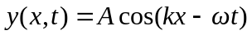
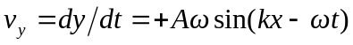
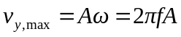
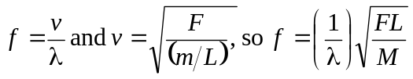
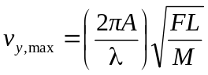

b) To double 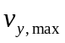 increase by a factor of 4

